

Create a web form that accepts a user's name and age. EXP.NO: 4 Write a Servlet to process the form data and display it
back on the browser.

AIM:

To create a simple web application that includes a form to accept a user's name and age, and then use a Servlet to process the submitted data. The Servlet will retrieve the form data, process it, and display the values back on the browser.

ALGORITHM:

1. Input:

• The user fills out a web form with their name and age and submits it.

2. Form Handling and Servlet Processing:

1. Create the Web Form:

o Create an HTML form with two input fields: one for the user's name and one for the user's age.

o Add a submit button to the form.

o Set the form's action attribute to the URL of the Servlet and the method to POST (or GET).

2. Create the Servlet Class:

o Write a Servlet that processes the form data submitted by the user.

o The Servlet will override the doPost() (or doGet() depending on the form method) to handle form submissions.

o The Servlet will retrieve the name and age parameters from the request object using request.getParameter("name") and request.getParameter("age").

3. Process the Data in the Servlet:

o Extract the name and age values submitted from the form.

o Validate the input (e.g., check if the age is a valid number).

o Prepare a response that will display the user's name and age back on the browser.

4. Send Response to the Browser:

o The Servlet will send a response to the browser containing a message like:

"Hello, [name]! You are [age] years old."
The response will be displayed to the user in the browser.

5. Deploy the Servlet:

o Compile the Servlet and deploy it to a Servlet container (like Apache Tomcat).

o Ensure the web.xml file or Servlet annotations are used to map the Servlet to the URL defined in the form's action attribute.

6. Test the Application:

o Open the web browser, fill in the form with the name and age, and submit it.

o The Servlet will process the data and display the message back to the user in the browser.

HTML File ( index.html ):

<html>
<head>
<title>Online Result Collector</title>
</head>
<body style="font-family:Arial;text-align:center;background:#dbeafe;">

<h1>ONLINE RESULT COLLECTOR</h1>

<form action="ResultServlet" method="post">

Name : <input type="text" name="name"><br><br>
Reg No : <input type="text" name="regno"><br><br>
Mark1 : <input type="number" name="m1"><br><br>
Mark2 : <input type="number" name="m2"><br><br>
Mark3 : <input type="number" name="m3"><br><br>

<input type="submit" value="Generate Result">

</form>

</body>
</html>

Java File ( ResultServlet.java ) :

import java.io.*;
import javax.servlet.*;
import javax.servlet.http.*;

public class ResultServlet extends HttpServlet {

public void doPost(HttpServletRequest request, HttpServletResponse response)
throws ServletException, IOException {

response.setContentType("text/html");
PrintWriter out = response.getWriter();

String name = request.getParameter("name");
String regno = request.getParameter("regno");

int m1 = Integer.parseInt(request.getParameter("m1"));
int m2 = Integer.parseInt(request.getParameter("m2"));
int m3 = Integer.parseInt(request.getParameter("m3"));

int total = m1+m2+m3;
double avg = total/3.0;

out.println("<html><body style='text-align:center;font-family:Arial;background:#0f172a;color:white;'>");
out.println("<h1>STUDENT RESULT SUMMARY</h1>");
out.println("<h2>Name : "+name+"</h2>");
out.println("<h2>Register No : "+regno+"</h2>");
out.println("<h2>Total : "+total+"</h2>");
out.println("<h2>Average : "+avg+"</h2>");
out.println("</body></html>");
}
}

File ( web.xml) :

<web-app>

<servlet>
<servlet-name>ResultServlet</servlet-name>
<servlet-class>ResultServlet</servlet-class>
</servlet>

<servlet-mapping>
<servlet-name>ResultServlet</servlet-name>
<url-pattern>/ResultServlet</url-pattern>
</servlet-mapping>

</web-app>

OUTPUT:

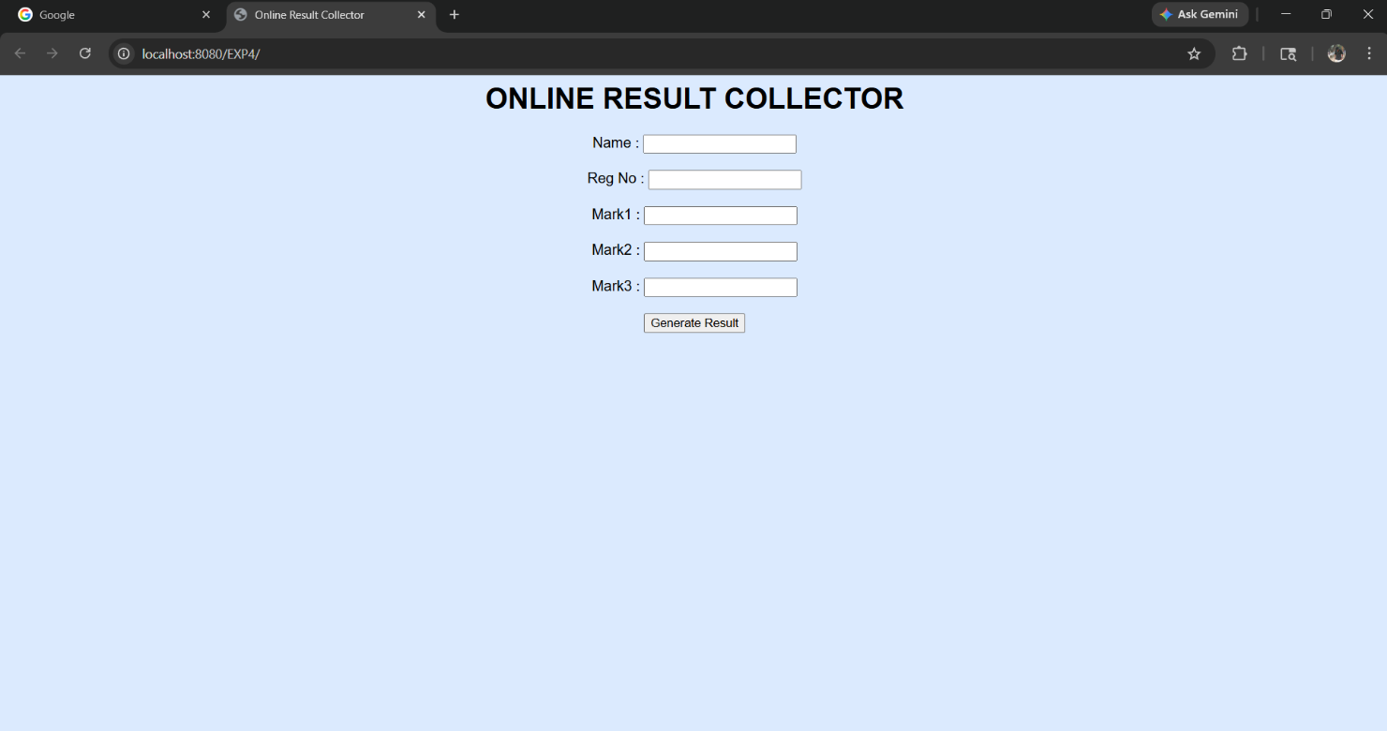

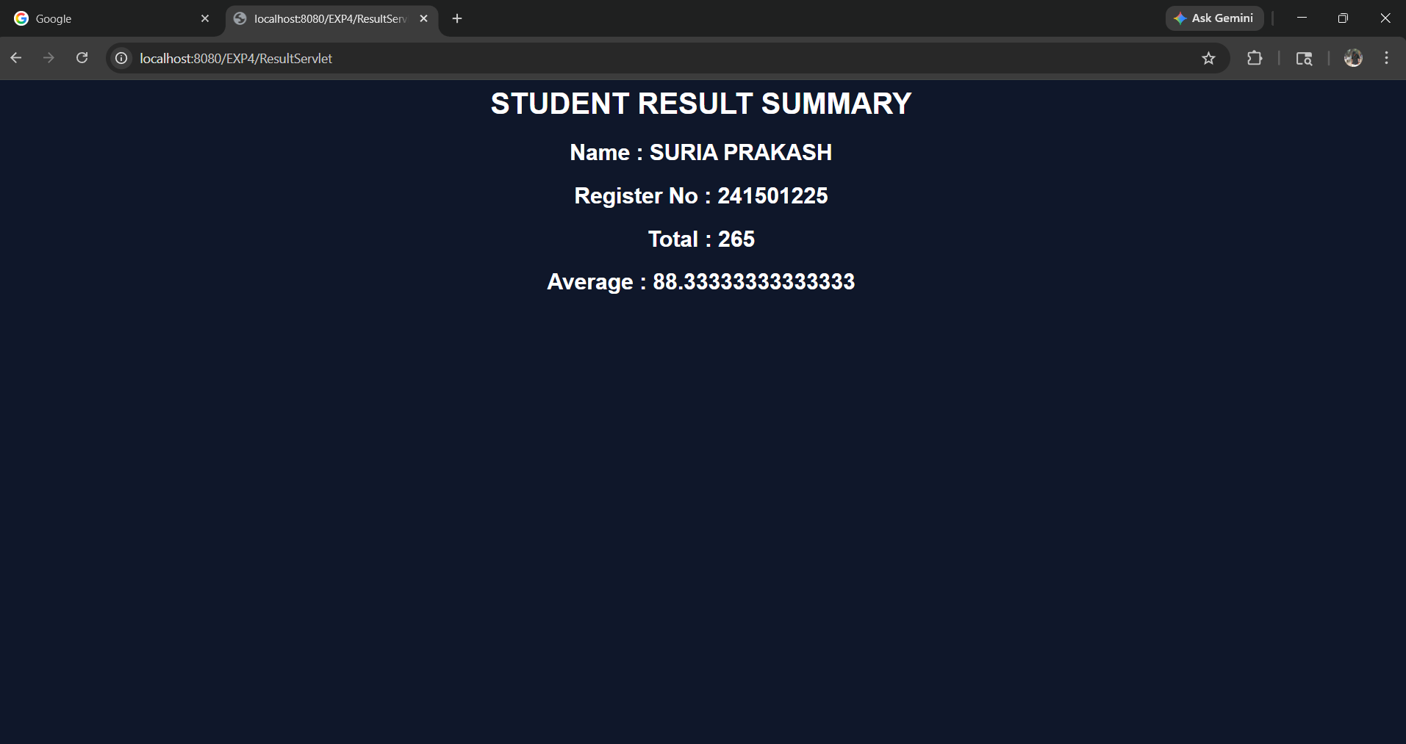

RESULT:
Thus A Servlet was created to process the HTML form data and display it back on the browser.

